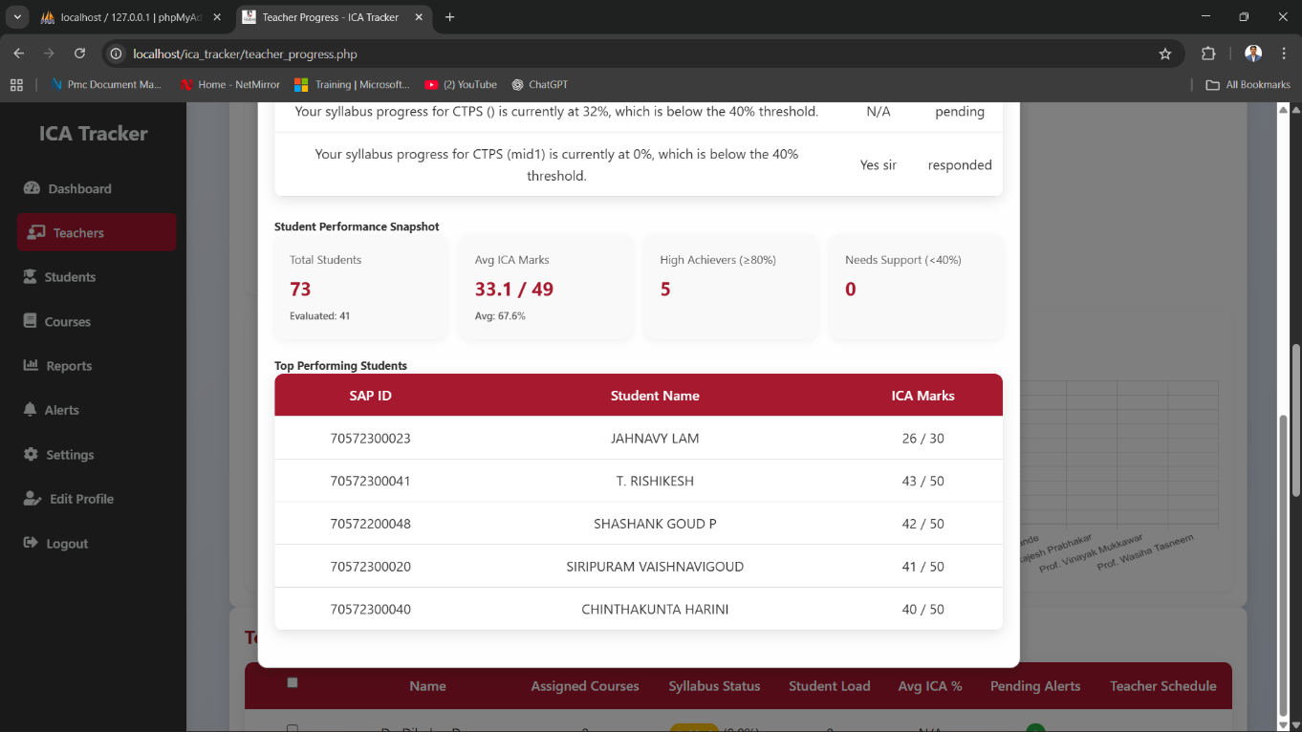
Here marks should be should only for 50 if 50 assigned or should show till 30 only for all students if it assigned for 30 only but here for some students it is showing 30 and for some students it is showing 50 of same class

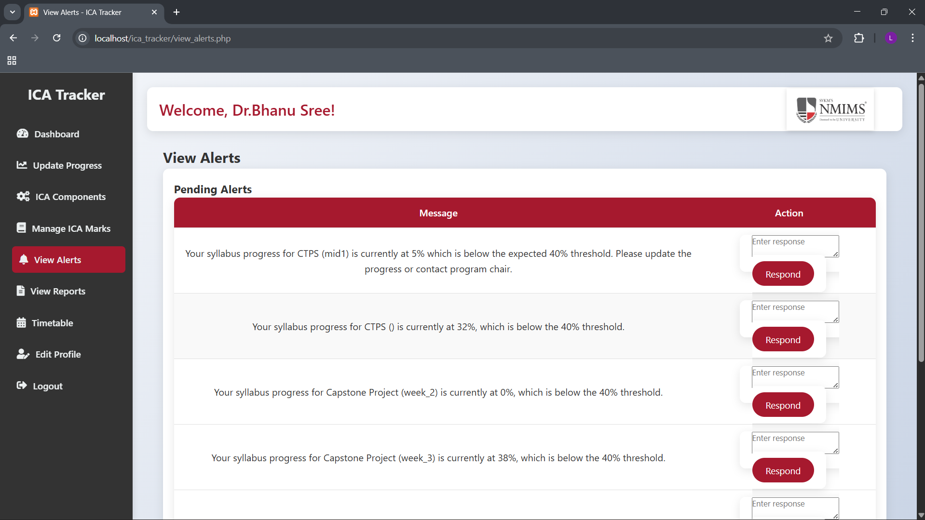
Here threshold will be 80 % not 40 percent and whatever the program chair adds in the settings page it should be considered

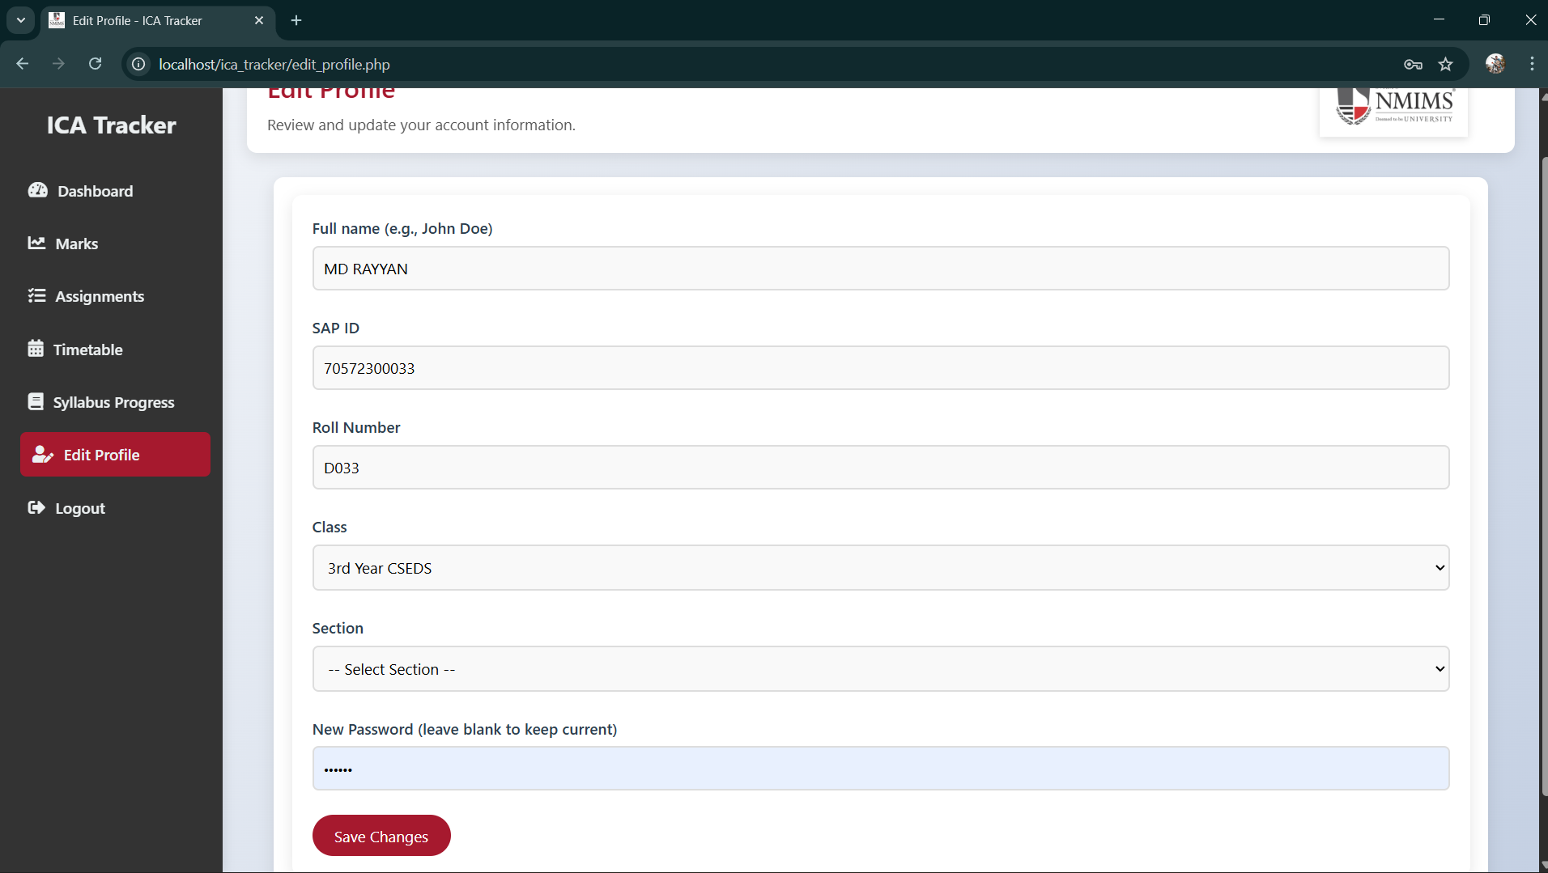
Students login appudu clg mail adagali
Mail nmims dhe undali
edit profile lo student mail edit option

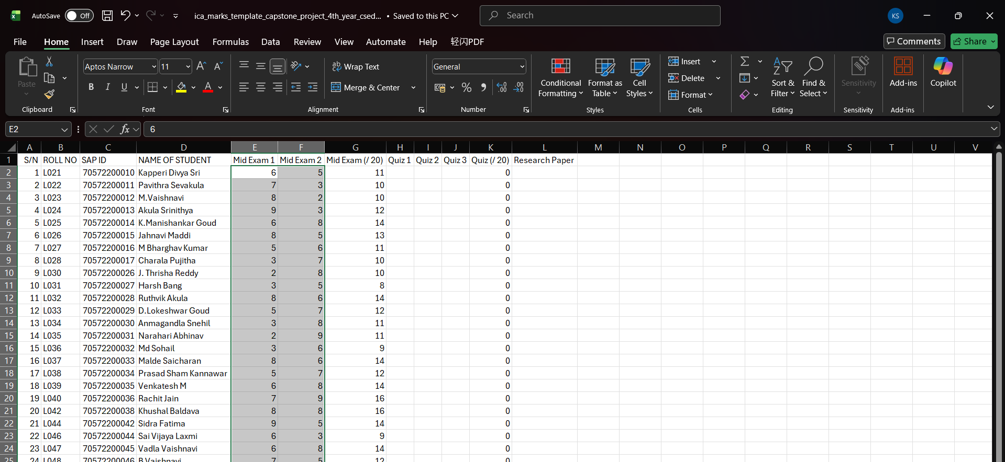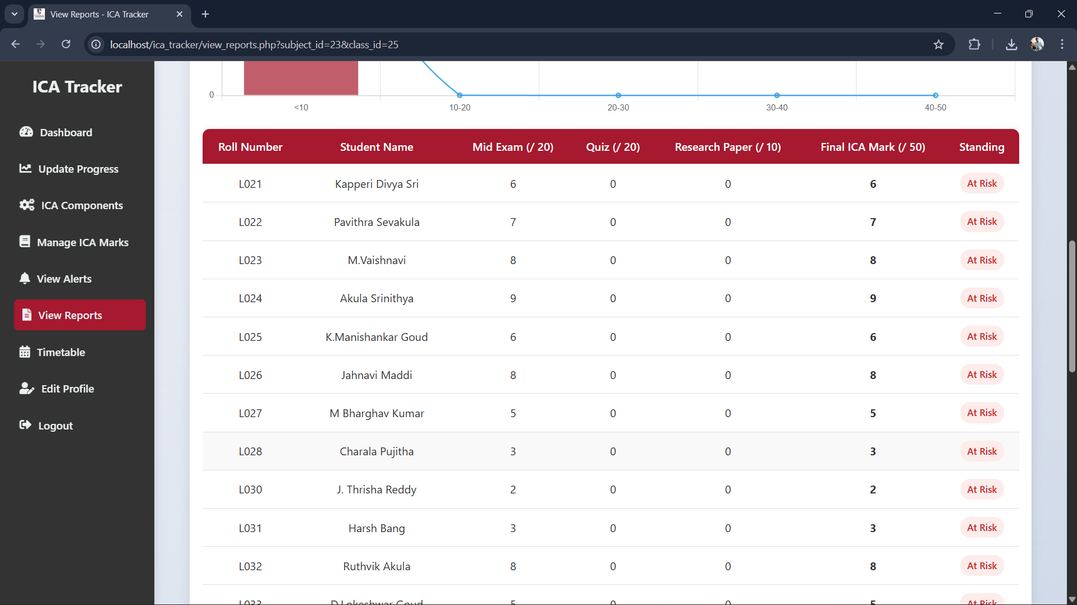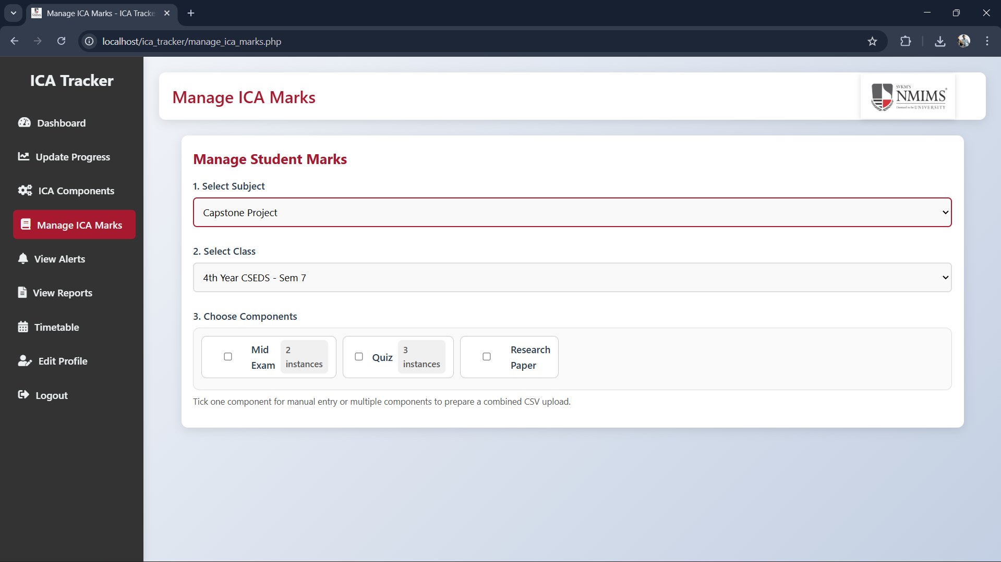here it is showing different different values in the excel values are correct values same values should be reflected in teacher dashboard porgram chair dashboard student dashboard

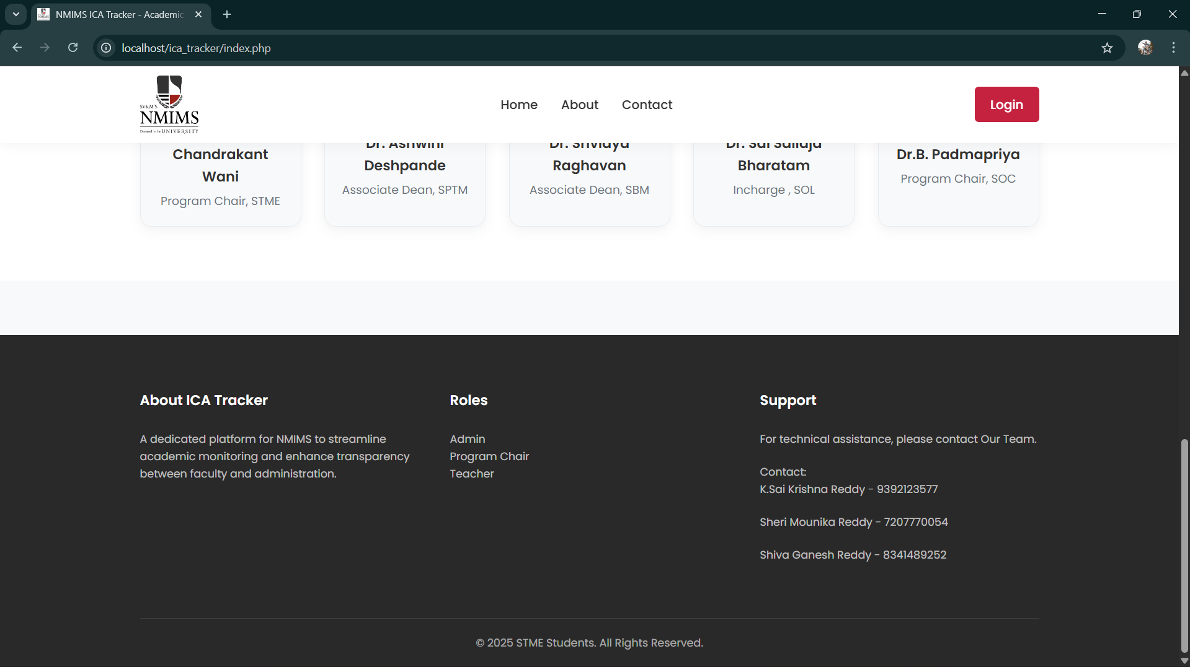here I want many changes as Contact below only sai krishna line should be present remove below 2 lines and
team details below the about ica tracker para as
Kuchuru Sai Krishna Reddy -70572300034 Batch 2023-2027 Btech CSEDS, STME
Sheri Mounika Reddy – 70572300032 same batch and all details repeat
Brungi Shiva Ganesh – 70572300021 same details
in footer 2025 Kuchuru Sai Krishna Reddy & Team . All Rights Reserved
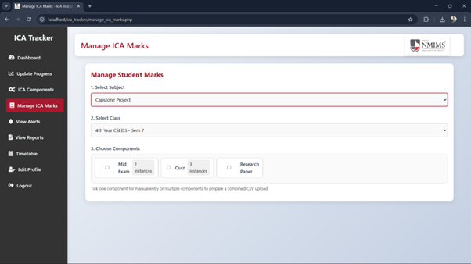 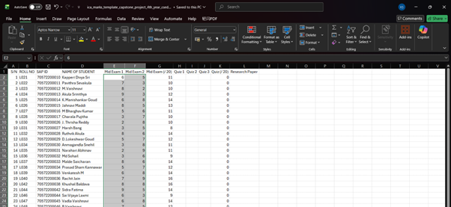 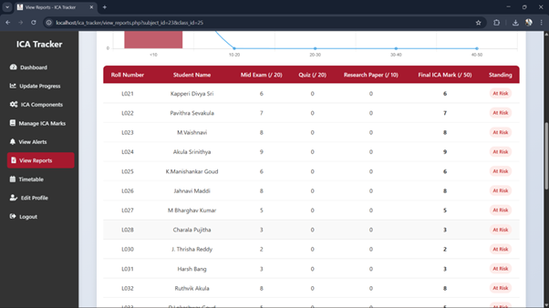 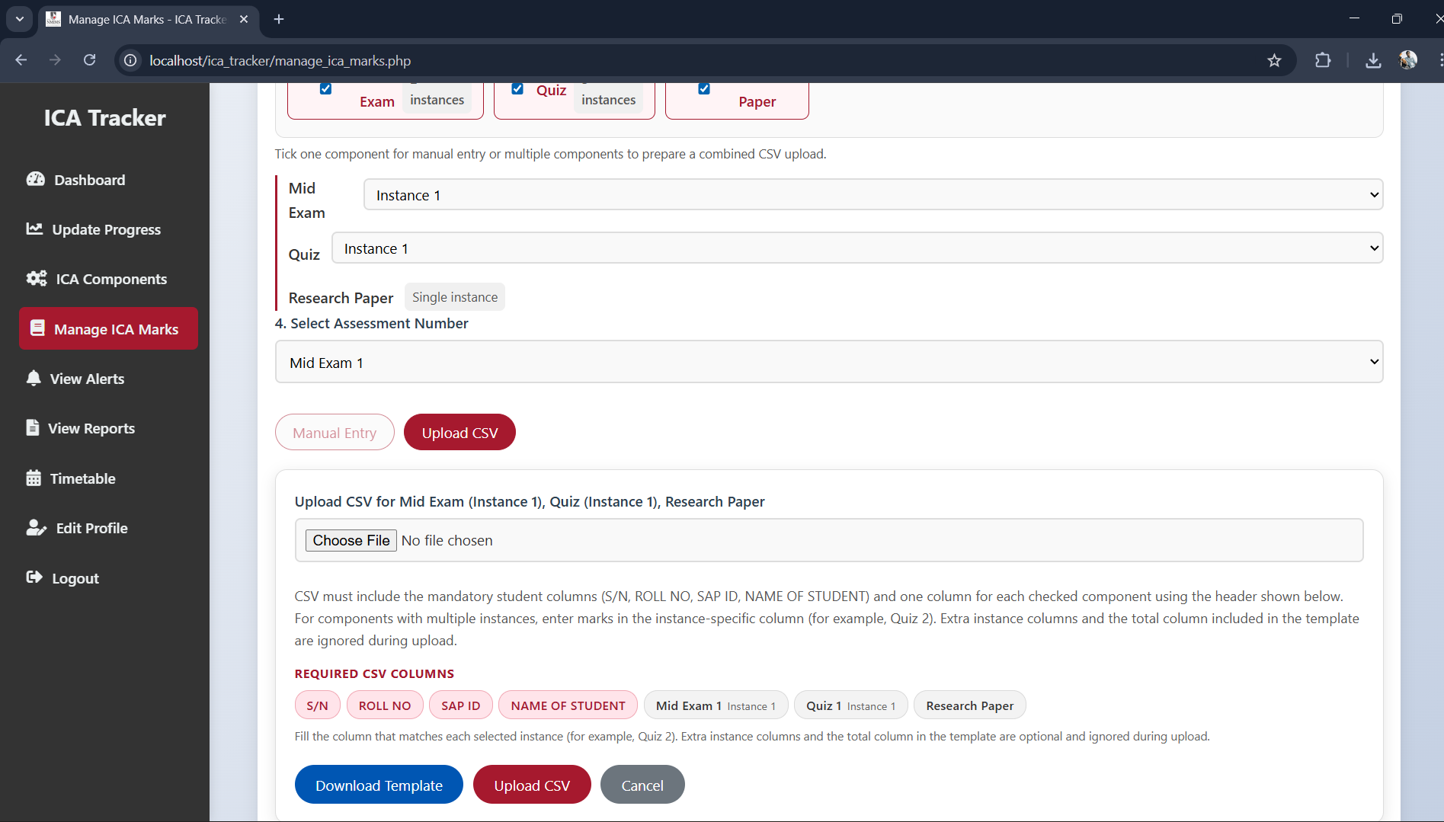
in excel Mid exam (/20) should be reflected in the all dshboards it is showing 6 marks it is wrong

here it is showing different different values in the excel values are correct values same values should be reflected in teacher dashboard porgram chair dashboard student dashboard
here while uploading remove the 1 instance that all directly he can upload the csv and it should read (/marks ) in the excel thats it
remove instances number while adding marks through csv
- Align every dashboard (teacher, program chair, student) so the “Mid Exam (/20)” column shows the same scaled totals as the CSV (e.g., 6 + 5 = 11).
- Remove the “Instance 1” dropdown from the CSV upload workflow so the template headers alone drive the upload.
- Make sure every CSV download always includes all components (with the required columns) even when nothing is pre-selected.

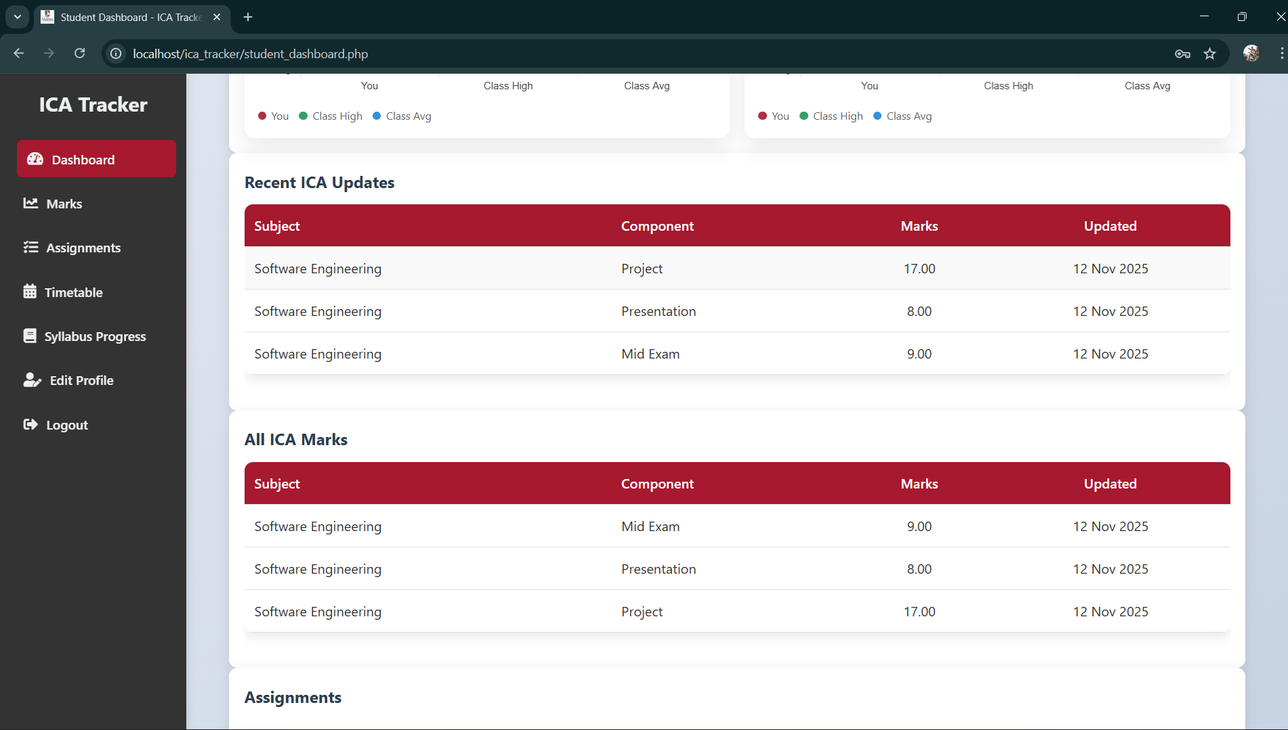after uploading marks in the teacher dashboard through upload csv it is not reflecting in the student dashboard once check this it is not reflecting the marks

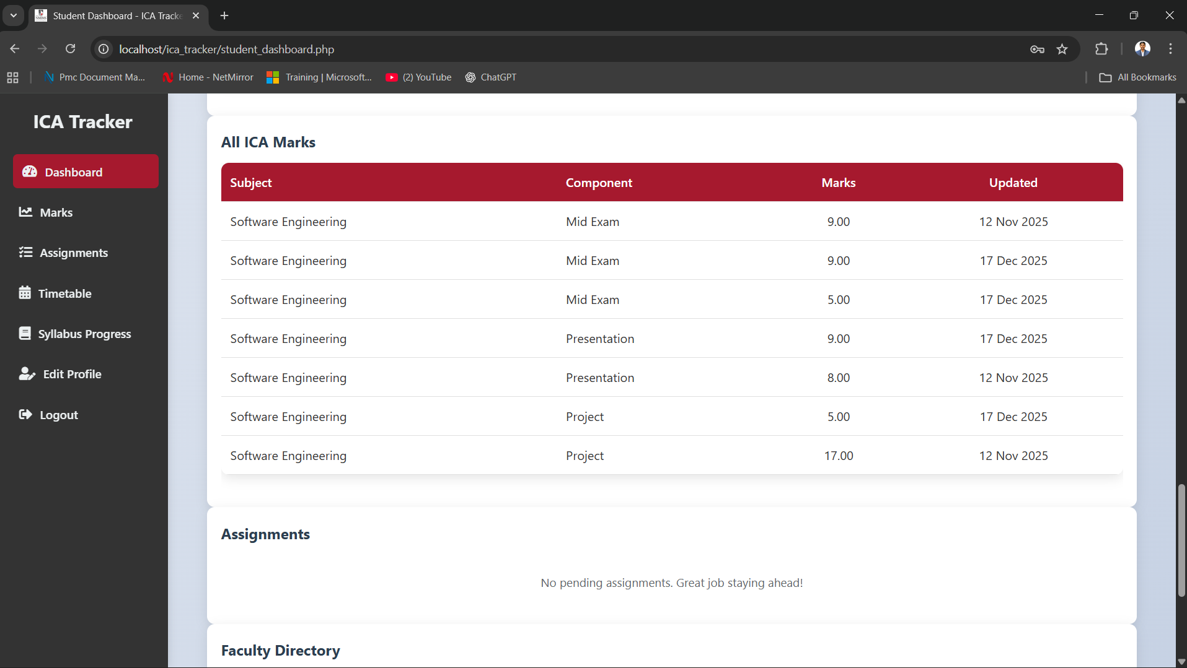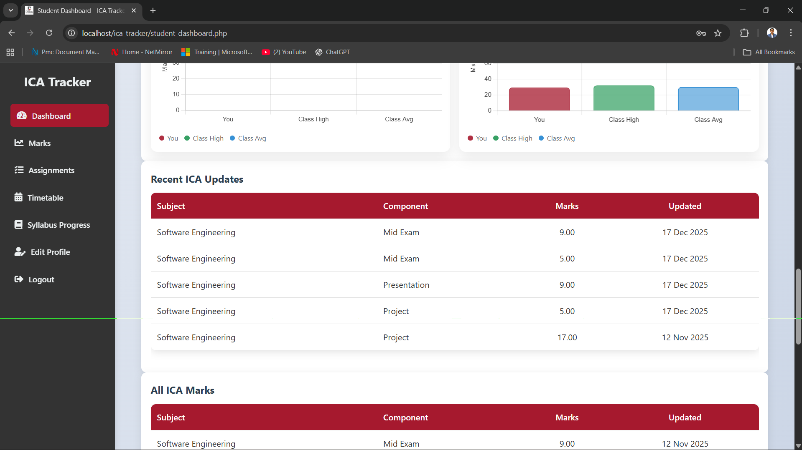

If two or three instances are duplicate check

